# WEEK 6

* **Ladder Diagram for Electric switch**
* Ladder diagrams are specialized schematics commonly used to document industrial control logic systems.
* They are called “ladder” diagrams because they resemble a ladder, with two vertical rails (supply power) and as many “rungs” (horizontal lines) as there are control circuits to represent.
* If we wanted to draw a simple ladder diagram showing a lamp that is controlled by a hand switch, it would look like this

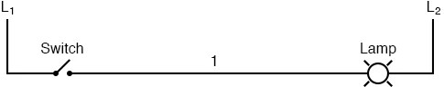

# Ladder Diagram for motor circuit

* Consider the simple wiring diagram for an electrical circuit in Figure a.
* The diagram shows the circuit for switching on or off an electric motor.
* We can redraw this diagram in a different way, using two vertical lines to represent the input power rails and stringing the rest of the circuit between them.
* Figure b shows the result. Both circuits have the switch in series with the motor and supplied with electrical power when the switch is closed.
* 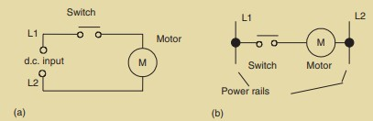The circuit shown in Figure b is termed a ladder diagram.

Ways of drawing the same electrical circuit

# Ladder Diagram for Belt Drive

* Detecting the standing bottles on the conveyor and pushing falling bottles in tray.

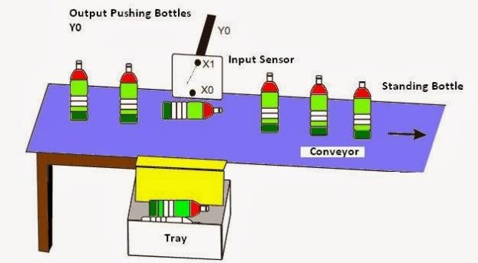

# Number of PLC Inputs Required

X0 – Proximity Sensor to sense bottom of the Bottle i.e. X0 = ON when the detected input signal from the bottle-bottom is sheltered.

X1 – Proximity Sensor to sense upper part of the Bottle i.e. X1 = ON when the detected input signal from the bottle-neck is sheltered.

# Number of PLC Outputs Required

Y0 – To operate Pushing Cylinder/Rod

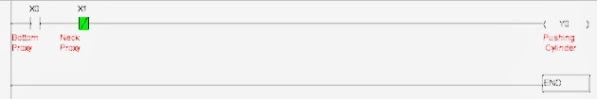

# LACTHING:

* There are often situations where it is necessary to hold an output energized, even when the input is removed.
* A simple example of such a situation is a motor, which is started by pressing a push button switch.
* Though the switch contacts do not remain closed, the motor is required to continue running until a stop push button switch is pressed. The term latch circuit is used for the circuit used to carry out such an operation.

# It is a self-maintaining circuit in that, after being energized, it maintains that state until another input is received.

* An example of a latch circuit is shown in Figure. When the input ‘A’ contacts closes, there is an output.
* These contacts are in the form of OR logic gate system with the input contacts. Thus, even if the input A opens, the circuit will still maintain the output energized. The only way to release the output is by operating the normally closed contact ‘B’.

# SEQUENTIAL OUTPUT:

* The sequencer output (SQO) instruction can be used to control output devices sequentially.
* The desired sequence of operation is stored in a data file or array, and this information is then transferred sequentially to the outputs.

# TIMER:

* In many control tasks there is a need to control time. For example, a motor or a pump might need to be controlled to operate for a particular interval of time or perhaps be switched on after some time interval.
* PLCs thus have timers as built-in devices.
* Timers count seconds or fractions of seconds using the internal CPU clock.

# Types of timers:

1. on-delay,
2. off -delay, and
3. Pulse.

* With small PLCs there is likely to be just one form, the on-delay timers.
* TON is used to denote on-delay, TOF off-delay, and TP pulse timers

1. **On-delay timers (TON)** come on after a particular time delay (Figure a).
2. **An off-delay timer (TOF)** is on for a fixed period of time before turning off (Figure b).
3. **Pulse timer (TP)** This timer gives an output of 1 for a fixed period of time (Figure c).

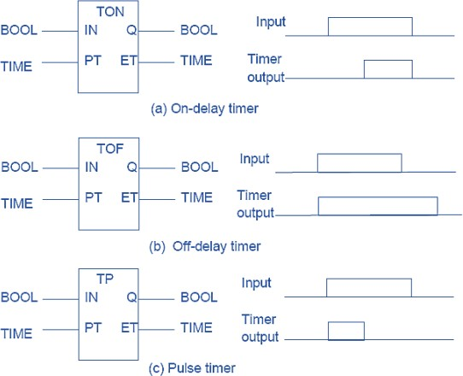

* Figure shows the IEC 1131-1 standard timers. Where BOOL indicates a Boolean input/output,

i.e. on/off. IN is the input. Q is the output. ET is the elapsed time output. PT is the input used to specify the time. Timers can be used for sequencing, cascaded and On off Cycle timer ladder programming.

* 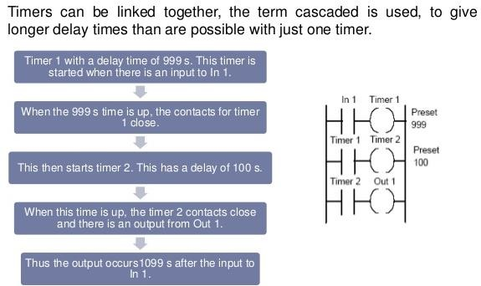**CASCADED TIMER:**

**ON-OFF CYCLIC TIMER:**

* + 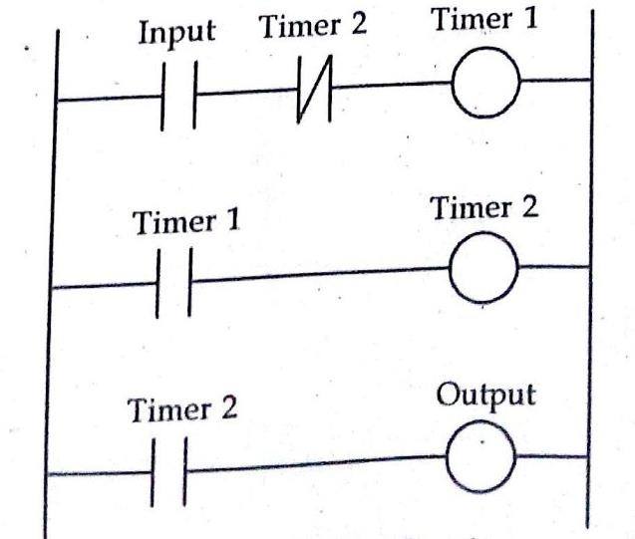Fig shows a program that can be used to cause an output ON 5s then OFF 5s & so on
  + When input contacts close, T1 is started & comes ON for 5s, this being time for which is pre-set.
  + After this time, T1 contact close & start T2, it comes ON after 5s, its pre-set time / & opens its contacts. This result in T1 being switched OFF.
  + This results in its contacts opening & switching OFF T1.This then closes its contacts & so entire cycle stars again.

# COUNTERS:

* Counters are provided as built-in elements in PLCs and allow the number of occurrences of input signals to be counted.
* Some uses might include where items have to be counted as they pass along a conveyor belt, the number of revolutions of a shaft, or perhaps the number of people passing through a door.

# Forms of Counter

* A counter is set to some preset number value and, when this value of input pulses has been received, it will operate its contacts. Normally open contacts would be closed, normally closed contacts opened.
* There are two basic types of counter: Down-counters and Up-counters.

1. Down-counters count down from the preset value to zero, that is, events are subtracted from the set value. When the counter reaches the zero value, its contacts change state. Most PLCs offer down-counting.
2. Up-counters count from zero up to the preset value, that is, events are added until the number reaches the preset value.

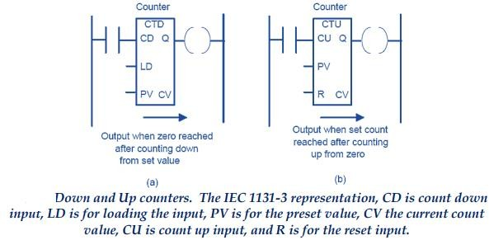

# SKILL EXPERIMENT NO 1

**AIM**: Develop PLC ladder diagram and timing diagram for the following Logic.

There are 3 mixing devices on a processing line A, B, C. After the process begin mixer-A is to start after 7 seconds elapse, next mixer-B is to start 3.6 second after A. Mixer-C is to start 5 seconds after B. All of them remain ON until a master enable switch is turned off.

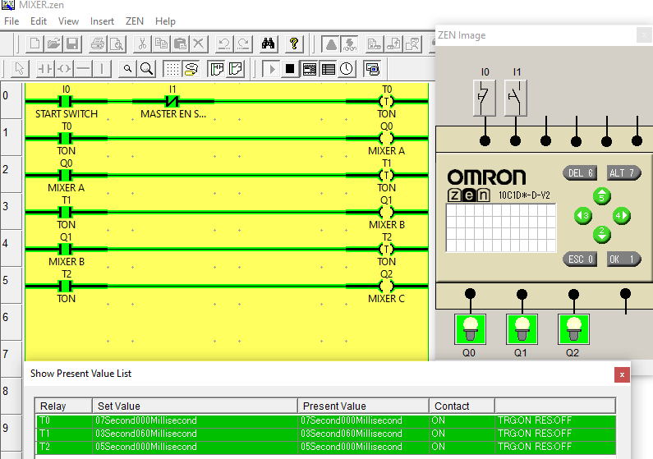

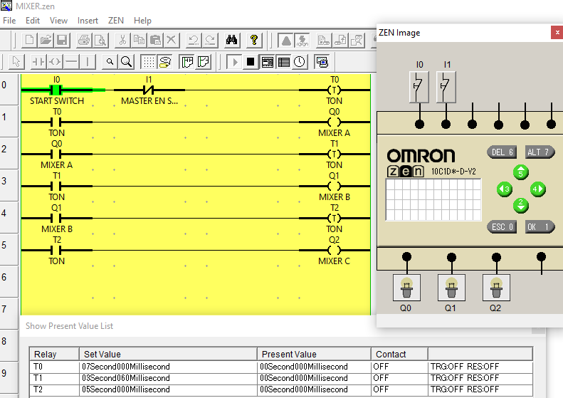

# EXPERIMENT NO 2

**AIM:** Write a Ladder Program to count the number of Items moving on a conveyor Belt and Execute/Simulate the same.

